Media release May 2022

THE JAVA QUARTET

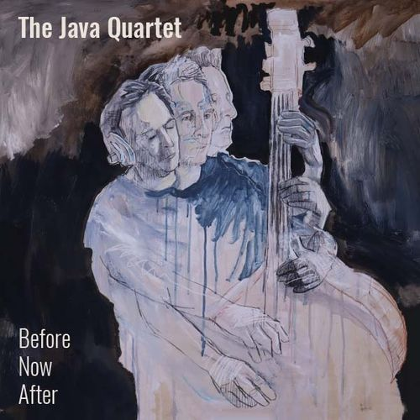

NEW JAVA QUARTET ALBUM ‘BERFORE NOW AFTER’ OUT NOW
ALBUM LAUNCH DATES ANNOUNCED

LINK TO LISTEN TO ALBUM (Soundcloud private link)
HERE

Free download and hard copies of album available on request to michaelgaleazzi@mac.com

The Java Quartet celebrate over 25 years with the release of their eighth album and a June launch.

The new album, Before Now After, continues the acoustic (and organic) nature of the group blending exotic grooves and melodies into the jazz harmonic world that is The Java Quartet. At once driving, trance-like and reflective, The Java Quartet establishes their own corner of sonic territory.

Recorded live at Free Energy Device Studio by long-time collaborator producer Keith Walker, Before Now After captures a two-day session of intuitive playing where the band explored melodic frameworks composed by Michael Galeazzi.

The three long form compositions represent an exposition on time, and the work springs from the Quartet’s 20 years of shared curiosity and their individual unique voices. Michael Galeazzi (bass), Matthew Ottignon (sax), Mike Quigley (drums), Greg Coffin (piano) have created a beautiful acoustic suite, spiced with groove, energy, and a sound that has been forged through a shared musical vision.

Before Now After is all that is typically Java: melodic, spacious, diverse, elegant and honest.

“The Java Quartet are popular without being desperately populist. They are inventive and distinctive without the need to be creative getting in the road of delivering enjoyment. They are catchy. Fans of various idioms feel it … influences from pop music as well as jazz and various ethnic musics are blended deceptively into the Java sound” John Clare

“The Java Quartet inhabits its own space, unlike that of any other aggregation, in Australia or anywhere else - supremely melodic, full of taut, yet limpid, grooves and packed with soul”.
Kenny Weir, Sunday Herald Sun

ALBUM LAUNCH DATES
Thursday 2 - June Foundry 616 Sydney
Tuesday 21 June - The Underground Grand Hotel Newcastle.
Friday 1 July - The Music Lounge, Wollongong
More dates to be announced

www.javaquartet.com.au

Before Now After is distributed by Dharma Records. Cat # DHR008, Release date May 2, 2022

MEDIA ENQUIRIES:
Tatiana Marchant
Estellar Publicity and Promotions
tatiana@estellar.com.au
+61 410 655 020

